# **Introduction**

Personal expenditure might differ from small amount to huge amount depending on how a person might spend money daily.

# **Aim**

Provide a data-driven mobile solution to the expense and income status for making better individual economic decisions.

# **Objectives**

* Working on Plans
  + Divide the whole research process into different sub-tasks
  + Arrange the tasks in a sequential order
  + Define a deadline for each task
* Research on expenses and incomes
  + Understand how a normal person uses his/her money in a day, week, and month
  + Learn about the income sources
  + Find different categories that a person spends money on
  + Identify the problems while managing economics
* Researching existing systems
  + Search and understand the workflow of the existing systems
  + Analyze the features of the system
  + Understand how the system taking advantages
  + Find the cons or challenges and missing features in the system
  + Compare existing systems with each other
  + Understand system culture
* Self-researching
  + Read research papers, documents, and articles
  + Find new useful functionalities for the system
  + Understand gamification on non-gaming app
  + Define system functionalities
  + Design a small concept system
* Challenges findings
  + Do pestle analysis
  + Do risk analysis
* System Development
  + Use the appropriate methodology, tools, and technology
  + Add quality attributes to the system
  + Add security and data backup to the system
  + Test the system
* Documentation
  + Start working on draft documents
  + Finalize the document's main contents
  + Use correct grammar and language
  + Add infographics
  + Structure and arrange the document contents in a logical order
  + Revise and proofread
  + Report submission

# **Justification**

Most people don’t keep records of how much money they are spending and earning. Sometimes people spend money on unnecessary things knowingly or unknowingly and the expense becomes greater than the income which might arise financial problems. Not keeping in mind their expenses and how much money is left could lead to such kind of problem. No one wants to spend money on unnecessary activities or things but it is hard to find those things without any kind of references. Those who have a tight budget and have to look after lots of things over a fixed time definitely should keep track of their expenses and income otherwise, they can run out of money. Therefore, if people can keep a record of how much money they are spending, where they are spending most, how much they are earning, where they are earning most, and look back to their income and expense history, then they will get an idea about how to handle their economic status and where to avoid spending money in the incoming days. Being careful and informed is the most important thing for better economic decisions rather than facing the problem, realizing what was the mistake, and then understanding what should be done next time.

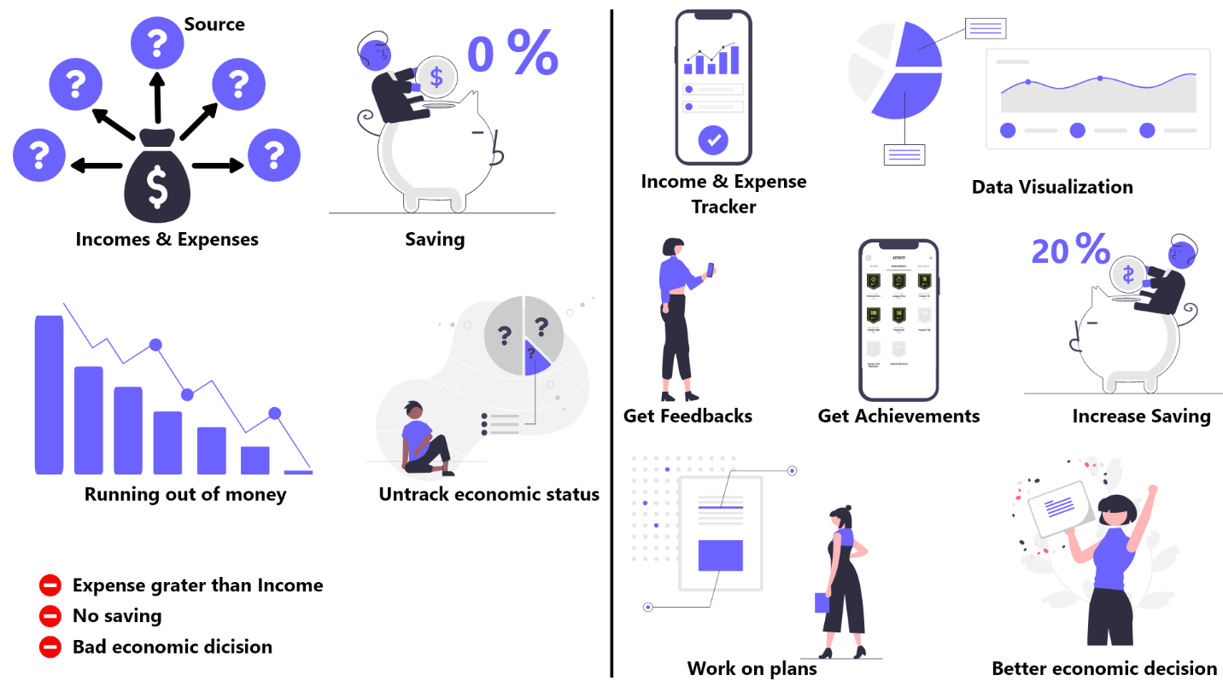

Figure 1: Solution to untrack expenses and incomes

A mobile app will be best suited for this solution because writing all the income and expenses in a textbook, or a text file will be time-consuming and bothering. People might use an excel sheet to keep a record of their expenses and income sources. But it will not be as much flexible as the mobile app while visualizing the data in many different ways. A mobile app will be simple, portable, easy, and fun to use. The app will save all the expenses and incomes of a user and give feedback if they are doing well or not. Users can access their data anytime wherever they want and their inserted data will be never lost because the data will be saved in the cloud. They can visualize their income and expenses based on daily, weekly, and monthly routines. They can also define a budget, add expenses to it, and get feedback if they are doing it well or not. They will get progress points, and badges and even can unlock achievements according to how regularly they insert data into the system and how well they will save money. This will motivate and encourage them to keep using the app more and more. Users can share their progress points and users with the high progress point will be listed on the ranking system. This will provide a healthy competitive environment. The app will answer the when, where, how much, and for what questions of their both incomes and expenses. This will help users to have better control and make better decisions about their expenses and incomes because they will start working on plans. They will avoid unnecessary spending, save money as much as possible, know the area where they are spending money most and less, and the high earning sources.